Query Tool

Author: $Author

Publisher: $Publisher

Date: $date
Query tool provides extra functions to retrieve MagicDraw elements using query language. Like any other Custom Tools, Query Tool (querytool.jar) must be installed in the 'extensions' folder of the Report Wizard plugin.and uses import directive to import a tool

\#import("query", "com.nomagic.reportwizard.tools.QueryTool")

You can find more information about Query Tool on MagicDraw ReportWizard UserGuide.pdf section Query Tool

Code learning:

- Retrieve an array of element by query pattern
\$query.get(query)

- Getting single result from query functions
Since MagicDraw model element does not have unique identified attribute so all methods will be return in Collection. Thus we will need convenient methods to get a single result from Collection. Additional methods for getting single result from query methods are:
  - Get the first element from collection
\$query.get(query).first()
  - Get the last element from collection
\$query.get(query).last()
  - Get the nth element from collection
\$query.get(query).get(index)
  - Get the unique element from collection (equivalent to first)
\$query.get(query).unique()

- Retrieve an array of elements by name
\$query.getElementsByName(name)

- Retrieve the element by ID
\$query.getElementById(id)

Example

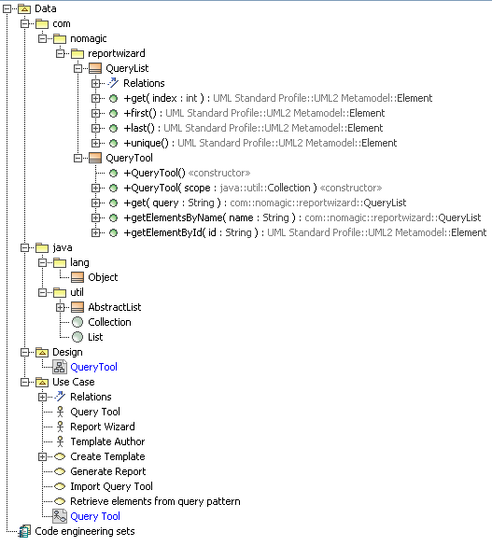
Figure 1 Query Tool Containment Tree

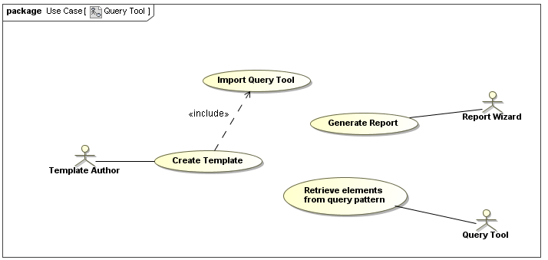

Figure 2 Query Tool Use Case Diagram

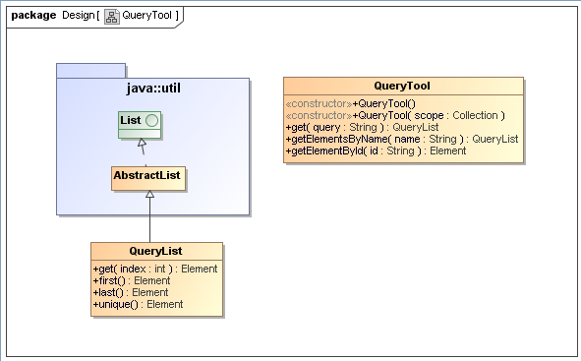
Figure 3 Query Tool Class Diagram

Try to create project elements according to above Query Tool use case and class diagram, then using following code:

#import("query", "com.nomagic.reportwizard.tools.QueryTool")

Retrieve array of element by Query Pattern

Example 1:
Print all packages containing in this project

Without QueryTool:
Name | Qualified Name
#foreach($c in $Package)
$c.name | $c.qualifiedName
#end

With QueryTool:
Name | Qualified Name
#foreach($c in $query.get("package"))
$c.name | $c.qualifiedName
#end

Example 2:
Print any classes whose containing in package reportwizard and name attribute start with Query

Without QueryTool:
Name | Qualified Name
#foreach($c in $Class)
#if($c.name.startsWith("Query") && $c.qualifiedName.indexOf("reportwizard") >= 0)
$c.name | $c.qualifiedName
#end
#end

With QueryTool:
Name | Qualified Name
#foreach($c in $query.get("class[qualifiedName*=reportwizard][name^=Query]"))
$c.name | $c.qualifiedName
#end

Or
Name | Qualified Name
#foreach($c in $query.get("package[name=reportwizard] class[name^=Query]"))
$c.name | $c.qualifiedName
#end

Example 3:
Print any classes that has no child

Without QueryTool:
Name | Qualified Name
#foreach($c in $Class)
#if($c.ownedElement.size() == 0)
$c.name | $c.qualifiedName
#end
#end

With QueryTool:
Name | Qualified Name
#foreach($c in $query.get("class:empty"))
$c.name | $c.qualifiedName
#end

Example 4:
Print any elements which owner is class QueryTool

Without QueryTool:
Name | Qualified Name
#foreach($c in $elements)
#if($c.owner.elementType == "class" && $c.owner.name == "QueryTool")
$c.name | $c.qualifiedName
#end
#end

With QueryTool:
Name | Qualified Name
#foreach($c in $query.get("class[name=QueryTool] > *"))
$c.name | $c.qualifiedName
#end

Example 5:
Print any elements whose containing in model Use Case and name ends with Tool

Without QueryTool:
#set($match = false)
#macro (recursiveCheck $e)
#if($e.elementType == "model" && $e.name == "Use Case")
#set($match = true)
#elseif($e.hasOwner())
#recursiveCheck($e.owner)
#end
#end

Name | Qualified Name
#foreach($c in $elements)
#set($match = false)
#if($c.hasName() && $c.name.endsWith("Tool"))
#recursiveCheck($c.owner)
#if($match)
$c.name | $c.qualifiedName
#end
#end
#end

With QueryTool:
Name | Qualified Name
#foreach($c in $query.get("model[name=Use Case] *[name$=Tool]"))
$c.name | $c.qualifiedName
#end

Getting single result from query functions
Print any classes in selected package

Name | Qualified Name
#foreach($c in $query.get("class"))
$c.name | $c.qualifiedName
#end

Print the first class in selected package

#set($c = $query.get("class").first())
Name | Qualified Name
$c.name | $c.qualifiedName

Print the last class in selected package

#set($c = $query.get("class").last())
Name | Qualified Name
$c.name | $c.qualifiedName

Print the nth class in selected package

#set($c = $query.get("class").get(1))
Name | Qualified Name
$c.name | $c.qualifiedName

Print the unique class in selected package

#set($c = $query.get("class").unique())
Name | Qualified Name
$c.name | $c.qualifiedName

Retrieve an array of elements by name
Print any classes whose name is QueryTool

Name | Qualified Name
#foreach($c in $query.getElementsByName("QueryTool"))
$c.name | $c.qualifiedName
#end

Retrieve the element by ID
Print element whose ID equivalent to the first class in selected package

#set($first = $query.get("class").first())
Name | Qualified Name
$first.name | $first.qualifiedName

#set($id = $first.elementID)
#set($c = $query.getElementById($id))
Name | Qualified Name
$c.name | $c.qualifiedName

